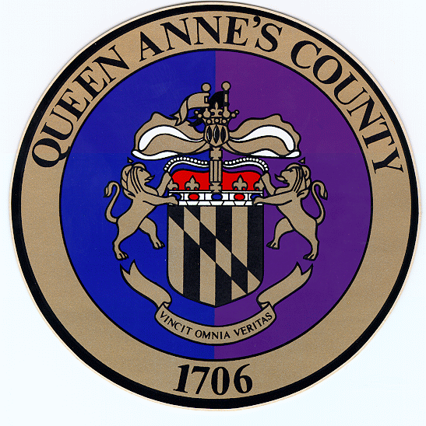
+ QUEEN ANNE’S COUNTY PLANNING & ZONING Permit #
PERMITS & INSPECTIONS Date
110 VINCIT STREET, SUITE 104
CENTREVILLE, MARYLAND 21617
410-758-4088

Public Event Permit Application
Application Must Be Submitted 30 Days Prior To Event
Organization:
Address:
Phone: |  | Email:
Type of Event: Bicycle Carnival Concert Sports Tournament Water Sport | Fair Festival Parade Run/Walk
 | Expected Attendance:
Event Name:
Event Address/Location:
Contact: |  | Phone:
Start Date: End Date:  From: _____/_____ /20___ To: _____/_____ /20___ |  | Start Time: End Time:  From: AM/PM To: AM/PM
Check all that apply: On private property On public property On school property On-site parking Food available to public Alcohol available to public Public restrooms available Temporary structures
Please include a drawing of the property showing the location of parking, any restrooms, any temporary structures, parade or race routes, and any vendor areas.
If food is available contact Environmental Health (410-758-2281) at the Queen Anne’s County Department of Health for a “Class 2 Temporary Food Service” application.
Are multiple vendors selling/providing food? Yes No
If yes, attach a list of the vendors along with their contact information with your application.
If food is being provided to the public to consume at the event/on site, describe how you will provide proper hand washing and supplies for the public to use.
Describe how you will dispose of the onsite solid waste during and after the event.

Will sidewalks or streets be impacted? Yes No
If yes, please explain:
In the event of an emergency, is there a public safety operational plan? Yes No
If yes, please explain or provide a copy of the plan:

Signature: |  | Date:
Comments:

Recycling is required for events that meet the following Special Events Recycling Program (SERP) criteria:
- Includes temporary or periodic use of a public street, publicly owned site or facility, or public park;
- Serves food or drink; and
- Is expected to have 200 or more persons in attendance. (Projected attendance may be estimated based on past attendance, number registered to attend, the venue’s seating capacity, or other similar methods.)
By signing below, the Special Events Organizer (SEO) certifies that:
- The SEO has received the SERP Fact Sheet;
- Recycling will be provided in accordance with the requirements of the SERP;
- The SEO will recycle (check all that apply); and
□ Cardboard □ Glass Containers
□ Plastic Containers □ Paper
□ Metal Containers □ Food Scraps
- Recycling will be performed by __________________ and materials delivered to __________________.

Please obtain all necessary permits, if any, including those that may be required from the agencies listed below:

Queen Anne’s County Community Affairs
110 Vincit Street, Suite 100
Centreville, MD 21617
Phone: (410)758-4418
Queen Anne’s County Department of Emergency Services
100 Communications Drive
Centreville, MD 21617
Telephone: (410)758-4500
Fax: (410)758-2086
Emergency: 911
Queen Anne’s County Department of Environmental Health
206 N. Commerce St
Centreville, MD 21617
Phone: (410)758-2281 Fax: (410)758-6602
Temporary Food Service Permit
http://dhmh.maryland.gov/qahealth/SiteAssets/permit_applications/tmpfood2.pdf
Queen Anne’s County Liquor Board
110 Vincit Street, Suite 104
Centreville, MD 21617
Phone: (410)758-1255
Queen Anne’s County Parks Department
1945 4-H Road
Centreville, MD 21617
Phone: (410)758-0835
Fax: (410)758-0566
Queen Anne’s County Public Schools
202 Chesterfield Avenue
Centreville, Maryland 21617
(410)758-2403 ext. 141
Queen Anne’s County Department of Public Works
312 Safety Drive
Centreville, MD 21617
Phone: (410)758-0920 Fax: (410)758-3341
SHA - Special Events Permits Application
https://www.roads.maryland.gov/OOTS/SHA%20SpecialEventsPermitProcessandInstructions.pdf
Maryland State Highway Administration
615 Morgnec Road
Chestertown, MD 21620
Telephone: (410)810-3245 Toll Free: (800)637-9740
FAX: (410)778-0851

