MDIA, INC. announces “2023 NEC Code Review” Seminar

MIDDLE DEPARTMENT INSPECTION AGENCY, INC.

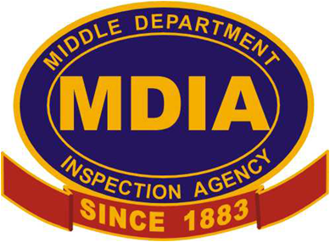

Tuesday June 10th, 2025

From: 7:30 AM to 1 PM at
QAC Planning & Zoning

110 Vincit Ct, Centreville

FEATURING:
- MDIA Inspectors
- Certificate of Completion good for 5 hours of Continuing Education.
- Maryland approved

Price is $100.00 non-refundable
Pre-registration required by June 4th, 2025.

REGISTRATION FORM-please write name exactly
as it appears on your electrical license.
Name: |  |  |  |  |  | Company:
Address:
Phone: |  |  |  |  |  | E-mail:
Number of Attendees & Names(Use Back if necessary):

❒ | Check |   | Credit/Debit | Credit Card No.: |  |  | Expire Date:
Zip code: |  |  | CVD Code: |  | Signature:
Remit payment info to: MDIA, Inc. 410-822-8300
8673 Commerce Drive, Unit 2, Easton, MD 21601

